Weak Primes
# Source: AI Source: Provided by: [Data Path: Persons Table -> ID Column: 1, Name_En Column: Motasem Essam] -> From: [ChatGPT] on [7/13/2026]
A weak prime is a prime number that is less than the arithmetic mean (average) of the nearest prime immediately before it and the nearest prime immediately after it.
Equivalently, a prime is weak if it is closer to the previous prime than to the next prime.
For example,
$$19$$
is a weak prime because its neighboring primes are
$$17\text{and}23,$$
and
$$19<\frac{17+23}{2}=20.$$
Weak primes are studied in number theory, prime gap analysis, and computational mathematics.

Definition
# Source: AI Source: Provided by: [Data Path: Persons Table -> ID Column: 1, Name_En Column: Motasem Essam] -> From: [ChatGPT] on [7/13/2026]
A weak prime is a prime number $p$such that
$$p<\frac{p_{\text{previous}}+p_{\text{next}}}{2},$$
where
- $p_{\text{previous}}$is the largest prime less than $p$,
- $p_{\text{next}}$is the smallest prime greater than $p$.
Equivalently,
$$p-p_{\text{previous}}<p_{\text{next}}-p.$$
That is, the gap to the previous prime is smaller than the gap to the next prime.

Rules for Weak Primes

1. The Number Must Be Prime
# Source: AI Source: Provided by: [Data Path: Persons Table -> ID Column: 1, Name_En Column: Motasem Essam] -> From: [ChatGPT] on [7/13/2026]
The number itself must be prime.
Example
$$19$$
is prime.

2. Consider Only the Nearest Neighboring Primes
# Source: AI Source: Provided by: [Data Path: Persons Table -> ID Column: 1, Name_En Column: Motasem Essam] -> From: [ChatGPT] on [7/13/2026]
Use the immediately preceding and immediately following prime numbers.
Example
For
$$19,$$
the neighboring primes are
$$17$$
and
$$23.$$

3. Compare the Prime with the Average of Its Neighbors
# Source: AI Source: Provided by: [Data Path: Persons Table -> ID Column: 1, Name_En Column: Motasem Essam] -> From: [ChatGPT] on [7/13/2026]
The prime must be less than the average.
Example
$$\frac{17+23}{2}=20.$$
Since
$$19<20,$$
19 is a weak prime.

4. Compare the Neighboring Prime Gaps
# Source: AI Source: Provided by: [Data Path: Persons Table -> ID Column: 1, Name_En Column: Motasem Essam] -> From: [ChatGPT] on [7/13/2026]
A weak prime satisfies
$$p-p_{\text{previous}}<p_{\text{next}}-p.$$
Example
For
$$19, \\ 19-17=2, \\ 23-19=4.$$
Since
$$2<4,$$
19 is a weak prime.

5. The First Prime Is Not Weak
# Source: AI Source: Provided by: [Data Path: Persons Table -> ID Column: 1, Name_En Column: Motasem Essam] -> From: [ChatGPT] on [7/13/2026]
The smallest prime,
$$2,$$
has no previous prime.
Therefore,
2 is neither weak nor strong.

6. Weak Primes Become Less Predictable
# Source: AI Source: Provided by: [Data Path: Persons Table -> ID Column: 1, Name_En Column: Motasem Essam] -> From: [ChatGPT] on [7/13/2026]
The occurrence of weak primes depends on the irregular spacing of consecutive prime numbers.

7. Infinitely Many Weak Primes Are Believed to Exist
# Source: AI Source: Provided by: [Data Path: Persons Table -> ID Column: 1, Name_En Column: Motasem Essam] -> From: [ChatGPT] on [7/13/2026]
It is widely believed that infinitely many weak primes exist, but this has not been proven.

First Weak Primes
# Source: AI Source: Provided by: [Data Path: Persons Table -> ID Column: 1, Name_En Column: Motasem Essam] -> From: [ChatGPT] on [7/13/2026]
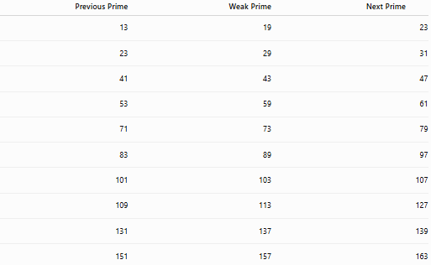
Previous Prime | Weak Prime | Next Prime
13 | 19 | 23
23 | 29 | 31
41 | 43 | 47
53 | 59 | 61
71 | 73 | 79
83 | 89 | 97
101 | 103 | 107
109 | 113 | 127
131 | 137 | 139
151 | 157 | 163

Examples
# Source: AI Source: Provided by: [Data Path: Persons Table -> ID Column: 1, Name_En Column: Motasem Essam] -> From: [ChatGPT] on [7/13/2026]
Example 1
Determine whether
$$19$$
is a weak prime.
Neighboring primes:
$$17, 23.$$
Average:
$$\frac{17+23}{2}=20.$$
Since
$$19<20,$$
19 is a weak prime.

Example 2
Determine whether
$$29$$
is a weak prime.
Neighboring primes:
$$23, 31.$$
Average:
$$\frac{23+31}{2}=27.$$
Since
$$29>27,$$
29 is not a weak prime; it is a strong prime.

Example 3
Determine whether
$$43$$
is a weak prime.
Neighboring primes:
$$41, 47.$$
Average:
$$\frac{41+47}{2}=44.$$
Since
$$43<44,$$
43 is a weak prime.

Example 4
Determine whether
$$59$$
is a weak prime.
Neighboring primes:
$$53, 61.$$
Average:
$$\frac{53+61}{2}=57.$$
Since
$$59>57,$$
59 is not a weak prime.

Example 5
Determine whether
$$73$$
is a weak prime.
Neighboring primes:
$$71, 79.$$
Average:
$$\frac{71+79}{2}=75.$$
Since
$$73<75,$$
73 is a weak prime.

Example 6
Determine whether
$$157$$
is a weak prime.
Neighboring primes:
$$151, 163.$$
Average:
$$\frac{151+163}{2}=157.$$
Since
$$157=157,$$
157 is not a weak prime; it is a balanced prime.

Common Weak Primes
# Source: AI Source: Provided by: [Data Path: Persons Table -> ID Column: 1, Name_En Column: Motasem Essam] -> From: [ChatGPT] on [7/13/2026]
Some well-known weak primes are
$$19, \\ 43, \\ 73, \\ 89, \\ 103, \\ 137, \\ 167, \\ 179, \\ 227, \\ 269.$$

How to Determine Whether a Number Is a Weak Prime
# Source: AI Source: Provided by: [Data Path: Persons Table -> ID Column: 1, Name_En Column: Motasem Essam] -> From: [ChatGPT] on [7/13/2026]
- Verify that the number is prime.
- Find the nearest prime immediately before it.
- Find the nearest prime immediately after it.
- Compute the average of the neighboring primes.
- If the number is less than this average, it is a weak prime.
Example
Check
$$43.$$
Neighboring primes:
$$41, 47.$$
Average:
$$\frac{41+47}{2}=44.$$
Since
$$43<44,$$
43 is a weak prime.

Real-Life Applications
# Source: AI Source: Provided by: [Data Path: Persons Table -> ID Column: 1, Name_En Column: Motasem Essam] -> From: [ChatGPT] on [7/13/2026]
Weak primes are primarily used in:
- Number theory research
- Prime gap analysis
- Computational mathematics
- Algorithm development
- Mathematical software
- Computer science
- Mathematics education
- Recreational mathematics
- Research on prime distributions

Real-Life Examples
# Source: AI Source: Provided by: [Data Path: Persons Table -> ID Column: 1, Name_En Column: Motasem Essam] -> From: [ChatGPT] on [7/13/2026]
1. Number Theory Research
Researchers study weak primes to analyze asymmetries in the spacing of consecutive prime numbers.

2. Prime Gap Analysis
Weak primes occur when the gap after a prime is larger than the gap before it.

3. Computational Mathematics
Algorithms classify primes as weak, balanced, or strong by comparing neighboring prime gaps.

4. Mathematical Software
Computer algebra systems generate lists of weak primes by examining consecutive primes.

5. Recreational Mathematics
Weak primes demonstrate that consecutive prime gaps are not uniformly distributed.

6. Mathematics Education
They provide a clear illustration of how averages and local spacing classify prime numbers.

Common Mistakes
# Source: AI Source: Provided by: [Data Path: Persons Table -> ID Column: 1, Name_En Column: Motasem Essam] -> From: [ChatGPT] on [7/13/2026]
- Confusing weak primes with composite numbers. A weak prime is still a prime.
- Using non-consecutive neighboring primes.
- Forgetting that only the nearest neighboring primes are considered.
- Confusing weak primes with balanced or strong primes.
- Assuming every prime must belong to a twin prime pair.

Key Points
# Source: AI Source: Provided by: [Data Path: Persons Table -> ID Column: 1, Name_En Column: Motasem Essam] -> From: [ChatGPT] on [7/13/2026]
- A weak prime is less than the average of its neighboring primes.
- Equivalently, the gap to the previous prime is smaller than the gap to the next prime.
- Weak, balanced, and strong primes classify interior primes according to neighboring prime gaps.
- The first prime, $2$, is neither weak nor strong because it has no previous prime.
- Weak primes are studied in number theory and prime gap analysis.

Weak Primes vs. Strong Primes
# Source: AI Source: Provided by: [Data Path: Persons Table -> ID Column: 1, Name_En Column: Motasem Essam] -> From: [ChatGPT] on [7/13/2026]
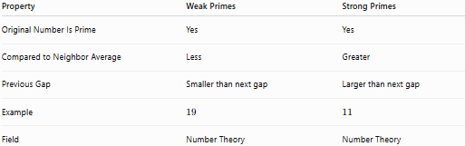
Property | Weak Primes | Strong Primes
Original Number Is Prime | Yes | Yes
Compared to Neighbor Average | Less | Greater
Previous Gap | Smaller than next gap | Larger than next gap
Example | $$19$$ | $$11$$
Field | Number Theory | Number Theory

Weak Primes vs. Balanced Primes
# Source: AI Source: Provided by: [Data Path: Persons Table -> ID Column: 1, Name_En Column: Motasem Essam] -> From: [ChatGPT] on [7/13/2026]
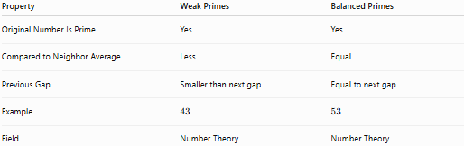
Property | Weak Primes | Balanced Primes
Original Number Is Prime | Yes | Yes
Compared to Neighbor Average | Less | Equal
Previous Gap | Smaller than next gap | Equal to next gap
Example | $$43$$ | $$53$$
Field | Number Theory | Number Theory

Classification of Interior Prime Numbers
# Source: AI Source: Provided by: [Data Path: Persons Table -> ID Column: 1, Name_En Column: Motasem Essam] -> From: [ChatGPT] on [7/13/2026]
Every prime number (except $2$, which has no previous prime) falls into exactly one of these three categories based on its neighboring prime gaps:
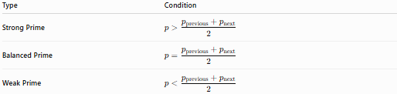
Type | Condition
Strong Prime | $$p>\frac{p_{\text{previous}}+p_{\text{next}}}{2}$$
Balanced Prime | $$p=\frac{p_{\text{previous}}+p_{\text{next}}}{2}$$
Weak Prime | $$p<\frac{p_{\text{previous}}+p_{\text{next}}}{2}$$

Conclusion
# Source: AI Source: Provided by: [Data Path: Persons Table -> ID Column: 1, Name_En Column: Motasem Essam] -> From: [ChatGPT] on [7/13/2026]
A weak prime is a prime number that is less than the arithmetic mean of the nearest prime before it and the nearest prime after it. Equivalently, it is a prime whose following prime gap is larger than its preceding prime gap. Together with strong primes and balanced primes, weak primes provide a natural way to classify prime numbers according to the local spacing of consecutive primes. They are an important topic in number theory, prime gap analysis, and computational mathematics.

